1. Batch Normalization
BatchNormalization is a layer used in neural networks to normalize the output of the previous layer during training.
It is available in:
tensorflow.keras.layers.BatchNormalization
Simple Definition
Batch Normalization standardizes the inputs of a layer for each mini-batch so that the network trains faster and more stable. There's also layer normalization and group normalization, which normalize differently.

Why Batch Normalization is Needed
During training of deep neural networks:
- The distribution of activations keeps changing after every layer update.
- This problem is called Internal Covariate Shift.
Meaning:
Input distribution → keeps changing during training
This causes problems like:
- Slow training
- Gradient instability
- Vanishing / exploding gradients
- Difficult optimization
Batch Normalization fixes this.

What BatchNormalization Does
For every mini-batch:
- Compute mean
- Compute variance
- Normalize the data
- Scale and shift

Mathematical Steps
Suppose a mini-batch has values:
x1, x2, x3, ..., xm
Step 1: Compute Mean
$$μ_{B}=\frac{1}{m}\sum_{i=1}^{m}{x_{i}}$$

Step 2: Compute Variance
$$σ_{B}^{2}=\frac{1}{m}\sum_{i=1}^{m}{(}x_{i}-μ_{B})^{2}$$

Step 3: Normalize
$$\hat{x_{i}}=\frac{x_{i}-μ_{B}}{\sqrt{σ_{B}^{2}+ϵ}}$$
Where
ε = small number to avoid division by zero

Step 4: Scale and Shift
BatchNorm introduces two learnable parameters:
γ (gamma) → scale
β (beta) → shift
Final output:
$$y_{i}=γ\hat{x_{i}}+β$$
This allows the network to learn the optimal distribution.

Where BatchNormalization is Used
Usually placed:
Dense/Conv Layer → BatchNorm → Activation
Example:

from tensorflow.keras.layers import Dense, BatchNormalization
model = Sequential([
Dense(128),
BatchNormalization(),
Activation('relu')
])
For CNN:
Conv2D → BatchNorm → ReLU

Advantages of Batch Normalization
1 Faster Training
Training becomes much faster.
Example:
Without BN:
100 epochs
With BN:
30–40 epochs

2 Reduces Vanishing Gradient
Helps in deep networks like:
- CNN
- ResNet
- Transformer

3 Allows Higher Learning Rate
Training becomes stable even with large learning rates.

4 Regularization Effect
Acts like mild regularization → reduces overfitting.

Example Code
from tensorflow.keras.models import Sequential
from tensorflow.keras.layers import Dense, BatchNormalization
model = Sequential()
model.add(Dense(128, input_shape=(20,)))
model.add(BatchNormalization())
model.add(Dense(64, activation='relu'))
model.add(BatchNormalization())
model.add(Dense(1, activation='sigmoid'))

2. ImageDataGenerator
ImageDataGenerator is used for image preprocessing and augmentation.
It is available in:
tensorflow.keras.preprocessing.image.ImageDataGenerator

What ImageDataGenerator Does
It:
- Loads images from folders
- Preprocesses images
- Performs data augmentation
- Feeds images to the model in batches

Why It Is Needed
Deep learning models require large datasets.
But often we have limited images.
Example:
Cat images: 500
Dog images: 500
This is small.
ImageDataGenerator artificially increases dataset size by creating modified images.

Example of Data Augmentation
Original Image:
Dog
Augmented versions:
Dog rotated
Dog flipped
Dog zoomed
Dog shifted
Dog brightened
So 1 image → many variations.
This improves model generalization.

Common Parameters
1 Rescaling
Normalize pixel values.
0–255 → 0–1
Example:
rescale = 1./255

2 Rotation
Rotate image randomly.
rotation_range=40

3 Width Shift
Move image horizontally.
width_shift_range=0.2

4 Height Shift
Move vertically.
height_shift_range=0.2

5 Zoom
Zoom in/out.
zoom_range=0.2

6 Horizontal Flip
Flip images.
horizontal_flip=True
Example:
Left facing dog → Right facing dog

Example Code
from tensorflow.keras.preprocessing.image import ImageDataGenerator
datagen = ImageDataGenerator(
rescale=1./255,
rotation_range=40,
width_shift_range=0.2,
height_shift_range=0.2,
shear_range=0.2,
zoom_range=0.2,
horizontal_flip=True,
fill_mode='nearest'
)

Loading Images from Folder
Typical dataset structure:
dataset/
train/
cats/
dogs/
validation/
cats/
dogs/

Flow From Directory
train_generator = datagen.flow_from_directory(
'dataset/train',
target_size=(150,150),
batch_size=32,
class_mode='binary'
)

What Happens Internally
- Load images
- Resize images
- Apply augmentation
- Convert to tensor
- Send batch to model
Example flow:
Image → Resize → Augment → Normalize → Batch → Model

Training Example
model.fit(
train_generator,
epochs=10,
validation_data=validation_generator
)
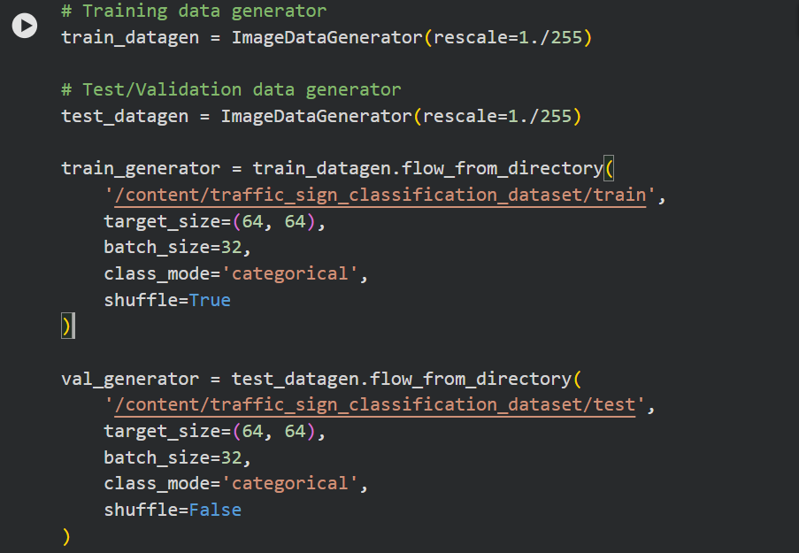
1️⃣ Import Concept: ImageDataGenerator

train_datagen = ImageDataGenerator(rescale=1./255)
ImageDataGenerator is a data preprocessing utility that:
- Loads images from disk
- Preprocesses them
- Generates batches of images for training
- Optionally performs data augmentation
Here we use:
rescale = 1./255
Images have pixel values:
0 – 255
Deep learning models work better when values are between:
0 – 1
So the transformation becomes:
$$\text{new pixel value}=\frac{\text{pixel value}}{255}$$
Example:
Original | After Rescale
255 | 1.0
128 | 0.50
0 | 0
This process is called normalization.

2️⃣ Training Data Generator
train_datagen = ImageDataGenerator(rescale=1./255)
This generator will be used for training images.
Currently it only performs normalization, but it could also do:
- rotation
- flipping
- zoom
- shear
Example augmentation:
ImageDataGenerator(
rescale=1./255,
rotation_range=20,
zoom_range=0.2,
horizontal_flip=True
)

3️⃣ Validation/Test Data Generator
test_datagen = ImageDataGenerator(rescale=1./255)
For validation/test data, we usually do not apply augmentation.
Why?
Because validation data must represent real unseen data, not artificially modified images.
So we only apply:
rescale

4️⃣ flow_from_directory() – Load Images from Folders
train_generator = train_datagen.flow_from_directory(
This function:
- Reads images from folders
- Converts them into batches
- Assigns labels automatically
- Feeds them to the CNN

5️⃣ Dataset Path
'/content/traffic_sign_classification_dataset/train'
This directory should look like:
train/
speed_limit/
img1.png
img2.png
stop_sign/
img3.png
img4.png
no_entry/
img5.png
Each folder name becomes the class label.
Example mapping:
speed_limit → 0
stop_sign → 1
no_entry → 2
Keras automatically creates this label encoding.

6️⃣ target_size=(64, 64)
target_size=(64,64)
All images will be resized to 64×64.
Why?
CNN models require same input dimensions.
Example:
Original Image | Resized
200×200 | 64×64
500×400 | 64×64
This ensures consistent input shape.
Final tensor shape becomes:
64 × 64 × 3
(3 = RGB channels)

7️⃣ Batch Size
batch_size=32
Instead of loading all images at once, the generator loads:
32 images per iteration
Example:
Dataset size = 3200 images
Then:
3200 / 32 = 100 batches per epoch
Batch training helps with:
- memory efficiency
- faster training
- stable gradients

8️⃣ Class Mode
class_mode='categorical'
This is used for multi-class classification.
Your dataset has 85 traffic sign classes, so labels will be one-hot encoded.
Example:
Class | One Hot
Stop | [1,0,0]
Speed Limit | [0,1,0]
No Entry | [0,0,1]
If it were binary classification, we would use:
class_mode='binary'

9️⃣ Shuffle
Training data
shuffle=True
Images are randomly shuffled every epoch.
Example order:
Epoch 1 → A B C D
Epoch 2 → C A D B
This prevents the model from learning dataset order patterns.

Validation data
shuffle=False
We do not shuffle validation data because:
- predictions must align with labels
- evaluation metrics require correct ordering

🔟 Validation Generator
val_generator = test_datagen.flow_from_directory(
This loads images from:
/test
These images are never used for training, only for:
- validation
- accuracy calculation

📊 What the Generator Actually Produces
Each batch looks like:
X → images
y → labels
Example shape:
X: (32, 64, 64, 3)
y: (32, 85)
Meaning:
32 images
64x64 pixels
3 channels
85 classes

📌 When Training the Model
You will use:
model.fit(
train_generator,
validation_data=val_generator,
epochs=20
)
The generator continuously streams batches of images to the CNN.

1️⃣ Download the API Key from Kaggle
- Go to Kaggle → Profile → Account
- Scroll to API
- Click Create New API Token
It downloads a file named:
kaggle.json
Inside it should look like:
{
"username": "your_kaggle_username",
"key": "your_api_key"
}

2️⃣ Upload the File in Google Colab
Run:
from google.colab import files
files.upload()
Upload kaggle.json.

3️⃣ Configure Kaggle in Colab
Run this exactly:
!mkdir -p ~/.kaggle
!cp kaggle.json ~/.kaggle/
!chmod 600 ~/.kaggle/kaggle.json

4️⃣ Install Kaggle Library
!pip install -q kaggle

5️⃣ Test if Kaggle Works
!kaggle datasets list
If everything is correct, it will print many datasets.

6️⃣ Download Your Dataset
Now run:
!kaggle datasets download -d sarangdilipjodh/indian-traffic-signs-prediction85-classes

7️⃣ Extract the Dataset
!unzip indian-traffic-signs-prediction85-classes.zip

✅ After extraction you can use your earlier code:
ImageDataGenerator.flow_from_directory(...)
for training the CNN.

💡 Tip: Kaggle API download is much more reliable than manually uploading ZIP files to Colab, which is why you were getting corrupted ZIP errors earlier.

